# **Executive Summary**

Social enterprise organizations, particularly in the food and beverage sector, have taken on an ever-increasing presence as viable business ventures. With more and more organizations emerging under this umbrella, understanding how they work and how they drive success is evidently important in a socio-cultural, and socio-economic context. This research project explores and investigates the best practises implemented by social enterprise organizations within the food and beverage industry, with the main intent of utilizing the insights to create recommendations for the betterment of the Regent Park Catering Collective (RPCC). As the RPCC has a business goal of becoming a sustainably profitable organization, understanding the ulterior motives of social enterprises and what factors define their success is consequential in informing their business acumen and decision-making processes. The data for this study was derived from the construction of a content analysis frame, which segmented different attributes of 19 different social enterprise food and beverage related organizations in the Toronto area to develop greater insight on best practices. The major insights that form the basis for our recommendations are:

* 73.7% of organizations operate using a catering business model
* 89.5% of organizations had a social focus on unemployment
* 92.9% of catering businesses possessed their own commercial kitchens, allowing for centralized command and control.
* Only 5.3% of food and beverage social enterprises were using an app-based distribution channel, representing a significant opportunity for competitive advantage in this market.

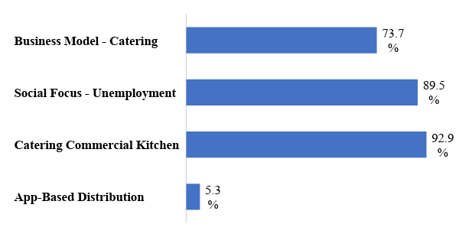

Some of the suggestions and recommendations drawn from this study are:

* For the RPCC to implement a proper employment structure.
* Continue to utilize a sufficient e-commerce platform to create further and sustainable business reach.
* Implement an app-based distribution platform, to streamline their business.
* Maintain their future commercialized kitchen which will enhance their business strategies and assist in their transition to a sustainably profitable organization.

Through these recommendations the RPCC has a true opportunity to expand their business, increase their exposure, and truly reap the benefits of working under a profitable business framework. These recommendations were mainly reached through a review of academic literature, an understanding of best practices, and a thorough investigation of the commonalities seen between the literature and the content analysis. Overall, through this report a more succinct understanding of how social enterprises function was developed, creating a pristine opportunity, to not only create recommendations for the RPCC. But to understand gaps in the research, limitations and pain points, and any potential opportunities for future studies to be conducted on this unique topic.